


Programme for Accelerated Community Development
2025 Annual Report

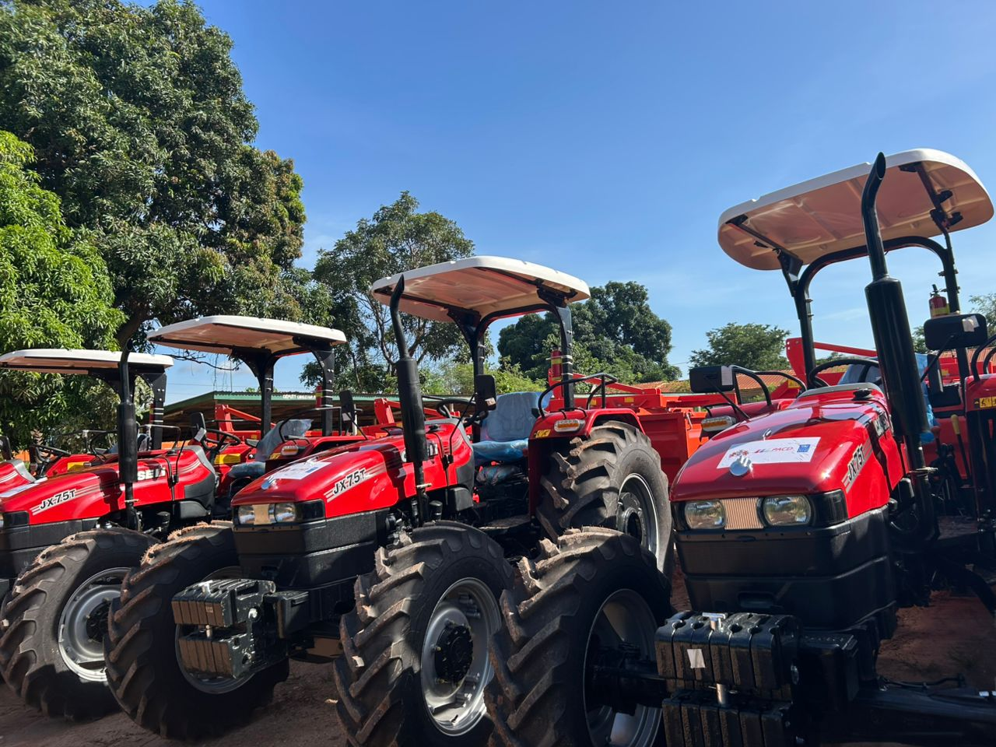

Date Submitted:

PROJECT INFORMATION
Project Number: | 00120570
Reporting Period: | January – December 2025
RF-NDP Component: | Pillar 1- Building Community Resilience to address Shocks and Crises
Contributing to UNSDCF/CDP | Outcome 2: By 2028, marginalized and vulnerable people in The Gambia enjoy efficient social and economic inclusion and rights-based human development for reduced poverty and inequality.
UNDP CPDF Output(s) | Outputs 2.2.2: The poorest individuals and communities have access to gender responsive and inclusive livelihoods, regional and national programmes, decent jobs and employment in formal and informal sectors
Total Budget: | USD 7,375,760.76
Implementing Partner: | UNDP The Gambia
Project Manager: | Vacant
Cluster Team Leader: | Samba Batch Jallow
ACRONYMS
AES Agricultural Engineering Service
AWP Annual Work Plan
CRR Central River Region
DCD Department of Community Development
DSPD Department of Strategic Policy and Delivery
DWR Department of Water Resources
LRR Lower River Region
MoPS Ministry of Public Service
NAWEC National Water and Electricity Company
NBR North Bank Region
PACD Programme for Accelerated Community Development
PSC Project Steering Committee
SDGs Sustainable Development Goals
UNDP United Nations Development Programme
URR Upper River Region
WALIC West African Livestock Innovation Centre
WCR West Coast Region

TABLE OF CONTENTS
I. EXECUTIVE SUMMARY 5
II. CONTEXT BACKGROUND 5
III. RESULTS 6
A. OUTPUT 1: Improved rural access to potable water 6
B. OUTPUT 2: Improved rural access to Electricity 7
C. OUTPUT 4: Food Security (Postharvest and Processing Equipment and Exotic Livestock for milk production) 7
D. OUTPUT 5: Sustainability of Services and Assets 9
E. Coordination and information sharing mechanisms are functional 9
VI. GENDER TRANSFORMATIVE RESULTS 10
V. YOUTH EMPOWERMENT 10
VI. SUSTAINABILITY AND EXIT STRATEGY 11
VII. PARTNERSHIPS 11
VIII. CHALLENGES 12
IX. RECOMMENDATIONS 12
X. LESSONS LEARNED 13
XI. ANNEXES 14
Annex 1: FINANCIAL TABLE 14
ANNEX 2: EXPENSES BY OUTPUT 14
ANNEX 3: RISK LOG 16
ANNEX 4: HUMAN INTEREST STORIES 18
ANNEX 5: PHOTOS 19

EXECUTIVE SUMMARY
In 2025, the Programme for Accelerated Community Development (PACD) delivered transformative results spanning rural electrification, water access, agricultural mechanization, and livestock production, contributing to inclusive development and resilience in line with national priorities and the SDGs. The year primarily served as a bridging and consolidation phase for the PACD project, during which results stemmed largely from activities initiated and contractually committed and carried over into 2025 due to procurement timelines and logistical considerations. As such, implementation in 2025 focused mostly on completing, operationalizing, monitoring, and ensuring the sustainability of prior investments, rather than initiating new activities.
Rural electrification interventions achieved full infrastructure delivery across six communities, with over 416 electricity poles erected and connected, significantly improving access to reliable electricity services. The intervention has generated transformative socio-economic benefits, including improved household living conditions through increased access to refrigeration, information, and communication services.
Food security was significantly strengthened through integrated investments in agricultural mechanization and livestock productivity. The delivery of nine tractors across five regions benefited over 4,000 people by reducing manual labour, expanding cultivated land, and increasing crop yields, with some communities reporting double or triple harvests compared to previous seasons. Transparent community management systems and cost-recovery models generated revenues ranging from GMD 175,000 to GMD 214,000 per intervention site, which were reinvested into tractor maintenance and other community priorities, supporting the sustainability of production systems. Complementing these gains, livestock productivity improved, with beneficiary communities/master farmers benefitting through the distribution of 27 exotic dairy cattle, with 13 successful calvings recorded. Under adequate feeding conditions which stands out as a model of what is possible, milk production reached up to 15 litres per cow per day, contributing to improved household nutrition, diversified food sources, and increased income for beneficiary families.
Coordination and governance mechanisms remained robust. The Project Steering Committee (PSC) and annual planning retreat reinforced government leadership, approved the 2025 Annual Work Plan, and strengthened accountability and results-based management. These platforms ensured alignment with national priorities and fostered joint problem-solving among UNDP, government ministries, and technical partners, such as NAWEC.
Taken together, the 2025 results demonstrate that PACD has moved beyond delivering assets to building durable systems that communities can sustain, manage, and scale. By coupling infrastructure and productive investments with strong governance, cost-recovery mechanisms, and local capacity, the programme has anchored a model of development that is not only impactful but self-sustaining. The priority going forward is clear: consolidate these gains, close remaining gaps, and leverage this foundation to accelerate inclusive, resilient growth at scale.

CONTEXT BACKGROUND
- Summary of background
The Programme for Accelerated Community Development (PACD) model provides a vehicle for a multi-sectoral approach to addressing poverty and inequality at community level and will help the Government to respond to social demands through a partnership with development partners to ensure accelerated, multi-pronged, participatory, and accountable delivery of services, particularly for hard-to-reach populations. This will revitalize and transform the economy for the well-being of all Gambians and particularly address the persistent and serious disparities between urban and rural areas in terms of access to basic services, including water, energy and road infrastructure as well as addressing existing inequalities, and disparities in access to socio-economic infrastructure.
The model aligns with international development norms aiming to keep people out of poverty through a multi-dimensional approach. It will help unleash further opportunities to strengthen national capacities, promote south-south cooperation and more importantly, improve the conditions of the people, particularly women and girls in poor communities. The Gambia has not had a strong record of government cost-sharing but with the entry of the new government in 2017, this initiative provided an opportunity to move into this approach.
Furthermore, PACD is a critical response to inclusive development for greater equity and social justice in line with the aims and aspirations of the National Development Plan and SDGs. This will ultimately result in achieving true national and inclusive development that enables all Gambians; wherever they are, to benefit from national resources in order to improve their living conditions by developing their local potential and enhancing access to basic social services.
- Project Objectives
To significantly improve the living conditions of people in rural areas through enhanced and sustainable access to basic socio-economic infrastructure and services, and the creation of local economies that promote sustained and inclusive socio-economic development, social justice, and equality.
- Project Outcomes/Outputs
- Output 1: Improved rural access to potable water
- Output 2: Improved rural access to Electricity
- Output 3: Improved rural roads (Not Activated)
- Output 4: Food Security (Postharvest and Processing Equipment and Exotic Livestock for milk production)
- Output 5: Sustainability of services and assets
- Implementing Partners
The West African Livestock Innovation Centre (WALIC), National Water and Electricity Company (NAWEC), Department of Community Development (CDC), Department of Water Resources (DWR), Ministry of Public Service Administrative Reforms, Policy Coordination and Delivery (MoPS), and Ministry of Agriculture, Livestock & Food Security.

III. RESULTS
- OUTPUT 1: Improved rural access to potable water
In 2025, a joint Government – UNDP monitoring visit led by the Hon. Minister of Public Service committed to undertake corrective maintenance of water facilities as a means of safeguarding the investments made under this component while also ensuring that the beneficiary communities accrue maximum benefits. Consequently, a 5.5 KW Inverter for the Sandi Kunda borehole /Solar water pumping system was procured and delivered leading to restoration of functionality of the water facility.
Meanwhile, the project continued engagements to support the construction and operationalization of two shallow boreholes serving the communities of Sare Modou Jawo, Mureh Kunda, Manakoto, and Kerr Ousman Busso. This intervention was envisaged to address longstanding water scarcity challenges and improve access to clean and safe water in the targeted communities. A decision is being sought to utilize the PACD Phase I project funds balance for this purpose.
A monitoring mission conducted in Sandy Kunda, Sare Talata, and Bursa Old/New confirmed the positive impact of the installed boreholes and associated taps on community wellbeing. The intervention has increased access to clean water for approximately 3,800 people, significantly reducing water scarcity–related challenges. Improved access to potable water has transformed daily life, particularly for women and girls who previously spent several hours fetching water. Time savings have enabled greater participation in education, income-generating activities, and household responsibilities, contributing to improved livelihoods and advancing gender equality. In addition, access to safe drinking water has enhanced hygiene and sanitation practices and improved overall health outcomes, including a reduction in waterborne diseases.
- OUTPUT 2: Improved rural access to Electricity
Rural electrification reached full infrastructure milestones in six communities, Kuntair, Berending, Buniadu, Ndungu Kebbeh, Medinah Serign Mass, and Albreda with over 416 electricity poles erected and connected. Beyond infrastructure delivery, the intervention has translated into tangible improvements in livelihoods, well-being, and local economic activity. Households in electrified communities report better living conditions, with increased ownership of refrigerators and televisions, enabling improved food preservation and greater access to information and public service messaging. Access to refrigeration has also eliminated the need for long-distance travel to obtain cold water and ice, generating notable time and cost savings, particularly during the rainy season and Ramadan.
Electricity access has eased women’s unpaid labour burden by reducing reliance on time- and labour-intensive domestic tasks. The introduction of electric milling machines has replaced manual grain processing, freeing up time for household management and income-generating activities. At the community level, street lighting often supported through collective contributions has improved safety and security, reducing petty crime and enabling greater mobility at night.
The intervention has also stimulated local economic growth. Fishermen and seafood vendors are now able to preserve their catch, reducing post-harvest losses and increasing incomes, while small businesses selling cold drinks and food attract customers from surrounding areas. Across all communities, these changes are consistently described as transformative, marking a clear transition from intermittent or temporary access to electricity to a reliable, service-oriented system that enhances quality of life and strengthens economic resilience.
- OUTPUT 4: Food Security (Postharvest and Processing Equipment and Exotic Livestock for milk production)
Food security and rural livelihoods were significantly strengthened through integrated investments in agricultural mechanization and livestock productivity, contributing to increased agricultural production, improved household resilience, and enhanced income-generating opportunities across targeted communities.
The delivery of nine tractors across the Upper River Region (URR), North Bank Region (NBR), Central River Region (CRR), Lower River Region (LRR), and West Coast Region (WCR) benefited over 4,000 people by reducing manual labour, expanding cultivated land, and increasing crop yields, with some communities reporting double or triple harvests compared to previous seasons. Improved access to mechanized farming particularly benefited elderly farmers, women, and less physically able community members, while enabling households that previously lacked the capacity to cultivate land to participate in agricultural production for the first time. Beyond increased agricultural output, transparent community management systems and cost-recovery models generated substantial revenues that were reinvested into tractor maintenance and community priorities, contributing to the sustainability of the interventions and strengthening local ownership.
Complementing the mechanization support, the project also strengthened access to labour-saving technologies -while securing the investments made, through the maintenance and repair of labour-saving devices in Youna Angalleh, Kerr Bamba, Jimbala Ali Hincha, Sandu Misera, Song Kunda, Madina Samako, Pinai Mandinka, Mayork, Sibanor, and Berefet. This restored the functionality of essential processing equipment used for agricultural production and post-harvest handling, reducing manual labour demands, improving operational efficiency, and supporting women and youth who are often disproportionately engaged in labour-intensive agricultural processing activities. To further enhance productivity and strengthen post-harvest value addition, the project also procured and delivered two new complete decorticators to Jimbala Ali Hincha and Madina Samako communities. The provision of the equipment is expected to improve processing efficiency, reduce post-harvest losses, and strengthen household income generation through improved agricultural processing and value-chain activities.
The mechanization support also generated wider socio-economic benefits beyond crop production. Tractors supported road rehabilitation, transportation of construction materials, and implementation of community infrastructure and youth-led initiatives, improving mobility, connectivity, and access to services within and beyond beneficiary communities. In several locations, the tractors now serve both host villages and more than 55 surrounding communities, strengthening inter-community collaboration and expanding the reach of agricultural services.
To strengthen operational sustainability and local technical capacity, 18 tractor operators and 7 mechanics from across the five regions received practical training in tractor operation, driving, and maintenance. The hands-on training, enhanced local capacity for equipment management and continuity of operations, supporting sustained productivity gains and reducing labour constraints in targeted farming communities.
To further enhance agricultural productivity and strengthen post-harvest management, the project procured 16 agricultural threshers for distribution to beneficiary communities. Once operationalized, the threshers are expected to reduce post-harvest labour burdens, particularly for women and youth who are often responsible for manual threshing activities, while improving grain quality and reducing post-harvest losses. The intervention is expected to complement existing mechanization support by strengthening the agricultural value chain from land preparation through post-harvest handling, contributing to improved food security, productivity, and household income retention.
Livestock productivity and household nutrition were further strengthened through a partnership with WALIC, which was commissioned to procure and manage the distribution of 27 exotic dairy cattle to beneficiary communities and master farmers, with 13 successful calvings recorded during the reporting period, demonstrating the technical viability of the intervention under supportive conditions. Under adequate feeding conditions, milk production reached up to 15 litres per cow per day, contributing to improved household nutrition, diversified food sources, and increased household income through the sale of fresh milk, sour milk, and locally processed yoghurt.
However, monitoring findings highlighted that limited access to affordable and sustainable feed significantly constrained the overall performance and sustainability of the dairy intervention. Although pasture establishment activities were initially anticipated, beneficiaries reported that these were not implemented, limiting local fodder production and increasing dependence on commercial feed purchases. Beneficiaries indicated that a 50 kg bag of feed lasted approximately five days, creating substantial financial pressure on households. In some communities, prolonged feeding shortages contributed to livestock losses, including deaths of cows and calves linked to inadequate nutrition, as well as premature calving associated with physiological stress. Consequently, milk productivity in affected sites declined from initial averages of 9–15 litres per day to approximately 4–7 litres per day, reducing income generation potential and affecting overall intervention viability.
Despite these challenges, beneficiaries demonstrated resilience by sustaining limited dairy production and continuing small-scale milk sales that contributed modestly to household income and local food availability. In some cases, households invested personal savings of up to GMD 30,000 to sustain feed purchases, despite limited prospects for financial recovery in the short term. Overall, the findings demonstrate that while improved dairy genetics hold significant potential to improve nutrition, livelihoods, and rural incomes, long-term sustainability is highly dependent on integrated support systems, including access to affordable feed, pasture development, climate-resilient livestock management, and veterinary support services. The findings further underscore the importance of transitional feeding support and strengthened livestock production systems during the initial implementation period to safeguard the long-term viability and impact of the intervention.
- OUTPUT 5: Sustainability of Services and Assets
Transparent, community-led asset management systems have been established around the tractor interventions, strengthening local ownership, accountability, and the long-term sustainability of PACD-supported assets. With the active support of Department of Community Development, beneficiary communities operationalized asset management committees and developed structured service fee systems and cost-recovery mechanisms to support the maintenance and continued utilization of the tractors. These systems generated revenues ranging from approximately GMD 175,000 to over GMD 214,000 per intervention site within a four- to five-month period, demonstrating strong community uptake and demand for mechanization services. Revenue generated through tractor operations is being systematically reinvested into fuel procurement, routine maintenance, and agreed community development priorities, reflecting a gradual transition from short-term asset utilization toward sustainable community-based asset management, financial resilience, and local self-reliance.
- Coordination and information sharing mechanisms are functional
During the reporting period, the Project made significant strides in strengthening coordination, communication, and information-sharing mechanisms among implementing partners and government institutions. These efforts enhanced strategic alignment, accountability, and coherence across the project’s multisectoral interventions, ensuring that implementation remained results-oriented and responsive to national priorities. From 28 February to 7 March 2025 UNDP and GoTG officials convened for a review and planning retreat where they jointly reviewed 2024 implementation progress, identified challenges and best practices, and set the strategic direction for 2025 and beyond. The process reinforced government leadership and ownership under the Ministry of Public Service (MoPS), strengthened inter-agency collaboration, and deepened the institutionalization of coordination mechanisms within the project governance structure.
The retreat culminated in the development of the 2025 Annual Work Plan (AWP), which was guided by national development priorities, field-level lessons learned, and a focus on efficiency, sustainability, and local accountability. The exercise also generated actionable recommendations to enhance implementation efficiency, monitoring, and stakeholder engagement. These included measures to streamline reporting, improve field coordination, and strengthen data-driven decision-making across sectors.
Complementing the planning retreat, the Project Steering Committee (PSC), the project’s highest decision-making body, met during the reporting period to review progress, validate achievements, and approve the 2025 AWP. The session brought together 16 PSC members (4 females, 12 males) representing key partner institutions. The PSC meeting demonstrated strong governance, accountability, and responsiveness within the project management framework.
These meetings reinforced joint accountability between UNDP and Government partners, ensuring that PACD interventions remain aligned with national development priorities and deliver tangible results on the ground. The effective functioning of coordination platforms such as the PSC and the annual planning retreat illustrates the project’s institutional maturity and commitment to results-based management.
VI. GENDER TRANSFORMATIVE RESULTS
PACD interventions contributed to meaningful gender-transformative outcomes by reducing structural barriers that limit women’s time, mobility, productivity, and participation in local economies. Improved access to potable water significantly reduced the unpaid care burden traditionally borne by women and girls, freeing time for education, household management, and income-generating activities. This shift represents a critical change in daily time use and agency, particularly in rural settings where water collection previously consumed several hours each day.
Rural electrification further transformed gender dynamics by reducing reliance on physically demanding domestic and productive tasks. Access to electricity enabled the use of electric milling machines, replacing manual grain pounding and substantially reducing women’s physical workload and time spent on labour-intensive household activities. Improved household and community street lighting also enhanced safety, security, and mobility at night, increasing women’s confidence and participation in social and economic activities beyond daylight hours.
Agricultural mechanization and post-harvest support interventions also generated significant gender-responsive outcomes. Access to tractors reduced the intensity of manual farm labour, making agricultural production more accessible to women, elderly farmers, and less physically able community members. In addition, the maintenance and repair of labour-saving devices across beneficiary communities, together with the procurement and delivery of new decorticators and agricultural threshers, significantly reduced the burden of manual post-harvest processing activities that are predominantly undertaken by women and girls. These interventions improved processing efficiency, reduced time spent on manual threshing and grain processing, minimized post-harvest losses, and strengthened women’s participation in agricultural value-chain activities and small-scale income generation. The reduction in physically demanding agricultural tasks created opportunities for women to engage more actively in livelihood diversification, household management, and community participation.
Mechanization interventions also strengthened women’s participation in community governance and decision-making structures. Women participated in tractor management committees and local asset governance systems, enhancing their role in decisions relating to productive assets, service delivery, and community resource management. This reflects a gradual shift from women being viewed primarily as beneficiaries toward greater inclusion as contributors, leaders, and decision-makers within local development processes. Collectively, these interventions contributed to more equitable labour distribution, strengthened women’s agency, improved access to productive opportunities, and enhanced household livelihoods across beneficiary communities.
The project also took deliberate steps to strengthen women’s inclusion within coordination, governance, and strategic planning platforms. During the PACD 2025 Planning Retreat, women accounted for 4 of the 17 participants and actively contributed to discussions on strategic direction, implementation priorities, and operational planning. Similarly, female representation within the Project Steering Committee (PSC) reached 25%, ensuring that women’s perspectives are incorporated into project oversight and governance processes. These efforts reflect a growing institutional commitment to gender-responsive governance and inclusive decision-making, where women increasingly influence strategic processes rather than occupying symbolic roles. Their participation contributes toward building more inclusive, equitable, and accountable coordination mechanisms that better reflect the priorities and needs of diverse beneficiary groups.

V. YOUTH EMPOWERMENT
PACD advanced youth empowerment as a cross-cutting development priority by strengthening youth participation in rural livelihoods, technical service delivery, local governance, and economic activities. Through targeted interventions in agricultural mechanization, livestock development, and rural infrastructure, the project contributed to transforming young people from passive beneficiaries into active contributors to rural productivity, innovation, and community development. These interventions strengthened youth skills, employability, economic participation, and engagement in decision-making processes shaping local development pathways.
Mechanization interventions created significant opportunities for youth skills development and employment creation. The training of 18 tractor operators and 7 mechanics across the five project regions, of whom approximately 65% were youth, strengthened local technical capacity in tractor operation, maintenance, safety, and equipment management. The practical hands-on training enhanced youth employability while contributing to improved agricultural productivity and service delivery within beneficiary communities. By equipping young people with marketable technical skills, the project contributed to reducing rural unemployment and establishing a growing pool of skilled rural technicians capable of providing mechanization services both within and beyond their communities. The introduction of mechanized agriculture also increased the attractiveness of farming among young people by reducing the intensity of manual labour and aligning agricultural production with technology, innovation, and modern service delivery approaches.
Youth also benefited from interventions aimed at strengthening post-harvest processing and agricultural value addition. The procurement and distribution of threshers and decorticators, created opportunities for youth engagement in agricultural processing, equipment operation, and local enterprise development. In addition to benefiting from these technologies, youths are actively involved in operating the threshers, providing processing services within their communities and generating income through their participation in post-harvest activities. These interventions reduced labour-intensive processing activities while strengthening efficiency within local agricultural value chains, creating opportunities for youth participation in productive and income-generating activities linked to post-harvest handling, equipment operation, and service provision.
The expansion of electricity access in beneficiary communities further strengthened pathways for youth empowerment and economic inclusion. Improved access to electricity enhanced opportunities for youth engagement in small-scale businesses, food preservation, trading, communication services, and other income-generating activities that depend on reliable energy access. Electrification also improved access to information, communication technologies, and social connectivity, strengthening youth participation in economic and community life while reducing vulnerability to seasonal unemployment and economic shocks.
Collectively, these interventions strengthened youth agency, technical skills, productivity, and economic participation, contributing to more inclusive and resilient rural livelihoods. PACD’s integrated approach demonstrates how investments in mechanization, infrastructure, and productive assets can create sustainable opportunities for young people while strengthening local economies and reducing barriers to youth participation in rural development processes.

VI. SUSTAINABILITY AND EXIT STRATEGY
Sustainability is anchored in community ownership, transparent governance, and strengthened technical capacity. Tractor management committees have institutionalized cost-recovery models, generating revenues, which are reinvested into fuel, maintenance, and community priorities. Electrification interventions include defect liability provisions and community contributions for street lighting, signaling shared responsibility for upkeep.
The exit strategy focuses on embedding PACD interventions within national systems through government leadership under the Ministry of Public Service and sector ministries. Capacity-building for operators, mechanics, and livestock beneficiaries ensures continuity of operations beyond the project lifecycle. Integration of PACD into national development frameworks and alignment with SDGs further secures long-term sustainability and resilience.

VII. PARTNERSHIPS

The PACD Project continues to demonstrate the value of strategic, multi-sectoral partnerships in delivering integrated rural transformation. By leveraging the comparative advantages of key partners, including WALIC, NAWEC, DWR, DCD, AES, and other government institutions, the project enhanced implementation efficiency, technical quality, and strategic alignment with national priorities.

UNDP’s technical support further strengthened national capacities for results-based management and enabled more effective coordination. Through this integrated partnership model, PACD is evolving into a coherent, government-led platform for rural transformation, demonstrating how collaborative efforts can drive sustainable results and reinforce accountability.

These partnerships have enabled resource pooling, technical exchange, and joint accountability, ensuring that interventions are context-driven and sustainable. The PSC continues to serve as a coordination and oversight platform, bringing together government, UNDP, and other stakeholders to harmonize efforts, strengthen synergies, and ensure coherent and results-oriented delivery across all project components.

VIII. CHALLENGES
- Limited access to adequate and affordable livestock feed undermines the sustainability of dairy cattle intervention, leading to declining milk productivity, financial strain on beneficiaries, and, in some cases, livestock losses.
- Absence of pasture establishment inputs and insufficient post-distribution feeding support constrained on-farm fodder production and long-term viability of improved dairy breeds.
- Climate-related stressors, including heat stress and parasite exposure, further reduced livestock productivity and survival rates.
- Last-mile electrification gaps, including delays in power activation, and exclusion of some households from the original electrification planning, limited equitable access to electricity.
- In border communities, documentation constraints restricted tractor use across national boundaries, limiting access and optimal utilization for some farmers.
- Delays in obtaining replacement parts and filters affected timely maintenance of tractors in some locations.
- Delayed procurement and disbursement processes slowed the timely delivery of inputs and infrastructure materials.
- Weak documentation and reporting mechanisms at the field level, leading to challenges in consolidating performance data.
- Gender and youth inclusion require continuous attention to avoid marginalization in project benefits.
- Limited technical capacity among some beneficiaries in livestock management poses a risk to optimal utilization of the distributed dairy breeds.
- Uneven participation of women and youth in technical and coordination processes, indicating the need for more targeted inclusion strategies.
- Limited gender representation among tractor operators and mechanics, constraining immediate gender-transformative outcomes.

IX. RECOMMENDATIONS
- Complement livestock breed distribution with integrated support packages, including time-bound feed assistance, pasture establishment inputs, and continued veterinary and extension services, particularly during the first year of production.
- Strengthen climate-resilient livestock management practices to mitigate heat stress, disease, and parasite exposure.
- Accelerate resolution of last-mile electrification gaps by clarifying handover and maintenance responsibilities with NAWEC; and reinforcing contractor accountability under defect-liability provisions.
- Enhance sustainability of mechanization services through improved access to spare parts, standardized maintenance support, and strengthened linkages with agricultural engineering services.
- Improve planning alignment between asset deployment and agricultural calendars to maximize utilization and productivity.
- Enhance technical training for community-based structures to sustain and maintain PACD investments.
- Provide continuous technical training for livestock beneficiaries to enhance productivity and sustainability of the introduced dairy breeds.
- Enhance monitoring systems by establishing standardized data collection tools and clear performance indicators.
- Strengthen capacity-building initiatives for community-based asset management and maintenance.

X. LESSONS LEARNED
- Sustainable results are achieved when asset provision is paired with adequate post-delivery support, including feeding systems, maintenance, and technical assistance.
- Community ownership, transparent governance, and cost-recovery mechanisms significantly enhance sustainability, accountability, and social cohesion.
- Last-mile implementation and maintenance arrangements are critical determinants of equitable access and perceived impact, particularly in infrastructure interventions.
- Joint monitoring and community engagement enable early identification of risks, validation of results, and evidence-based course correction.
- Mechanisation can function as a local public good when managed collectively, generating spillover benefits across neighbouring communities.
- Joint reflection and evidence-based planning enhance ownership and collective accountability among partners. The 2025 Retreat demonstrated that participatory review processes yield more realistic and actionable plans.
- Institutionalizing coordination mechanisms within government structures ensures sustainability and continuity beyond project cycles.
- Government financial commitment is a strong indicator of national ownership and should be complemented by capacity development for long-term implementation.
- Empowering local committees to manage assets enhances accountability and long-term functionality.

XI. ANNEXES

Annex 1: FINANCIAL TABLE
Donor | REVENUE |  | EXPENSES | BALANCE | Remarks
Donor | Total Commitment (a) | Total Received (b) | Total Expenses f= d+e | Total Received minus Total Expenses g=(b-f) | Remarks
Gov’t of The Gambia | 290,000 | 290,000 | 232,263.41 | 57,736.59
Total | 290,000 | 290,000 | 232,263.41 | 57,736.59

ANNEX 2: EXPENSES BY OUTPUT
Project Output | Total Expenses | Delivery Rate | Remarks
CPD output:
Output 1
Output 1: Improved rural access to potable water | 0.00
Sub- Total output 1
Output 2
Output 2: Improved rural access to Electricity | 0.00
Sub- Total output 2
Output 4: Food Security (Postharvest and Processing Equipment and Exotic Livestock for milk production)
Output 4.1: Increased access to Labour Saving Devices | 102,403.33
Sub- Total Output 4.1 | 102,403.33 | 35.31%
Output 4.2
Output 4.2: Enhanced access to improved exotic Livestock Breeds
Sub-Total Output 4.2
Output 5
Output 5: Sustainability of services/assets | 24,244.23
Total Output 5 | 24,244.23 | 8.36%
Project Management/GMS/Staff Cost | 119,642.76 | 41.10%
Total Expenses: | 232,263.41 | 80.09%

ANNEX 3: RISK LOG
No | Description of Risk Event | Type of Risk | Impact of Risk & Likelihood | Mitigation Measures | Risk Owner | Last Update | Status
1 | Delays in procurement and implementation of Outputs 1 and 2 (Water and Electricity) | Operational | High Impact, Medium Likelihood | - Strengthen procurement planning and early initiation of processes.  - Establish clear procurement timelines and responsibilities.. | Project team | March 2025 | Mitigation in Progress
2 | Limited technical capacity among livestock beneficiaries to manage and sustain dairy breeds | /Programmatic | Medium Impact, High Likelihood | - Provide continuous technical training through WALIC and extension officers.  - Establish linkages with veterinary and agricultural advisory services.  - Conduct periodic on-site follow-up and mentoring. | Project team | March 2025 | Ongoing
3 | Weak data collection and reporting mechanisms at field level | Monitoring & Evaluation | Medium Impact, Medium Likelihood | Develop and roll out standardized M&E tools.  - Train implementing partners on data management and reporting. | Project team | March 2025 | Ongoing
4 | Delays in project implementation due to procurement and logistical bottlenecks affecting timely delivery of materials and equipment. | Operational | Medium Impact, Medium Likelihood | Strengthened coordination with procurement units, early planning of logistics, and close follow-up with suppliers and contractors. | Project team | September 2025 | Mitigation in Progress
5 | Limited participation of women and youth in technical training (tractor operation and mechanics), reducing inclusivity and gender-transformative impact. | Social/Programmatic | Medium Impact, Medium Likelihood | Encourage women and youth participation in future training rounds; collaborate with Ministry of Agriculture and local leaders to identify and nominate female and youth trainees. | Project team | September 2025 | Ongoing
6 | Potential maintenance gaps for tractors and electricity infrastructure due to limited technical and financial capacity at community level. | Sustainability/Operational | High Impact, Medium Likelihood | Strengthened local capacity through training, community ownership strategies, and linkage with relevant government departments for maintenance support. | Line ministries | September 2025 | Being monitored

ANNEX 4: HUMAN INTEREST STORIES
STORY 1
From Wrenches to Harvests: How One Tractor Changed Bolong Keita’s Story in Bakadaji
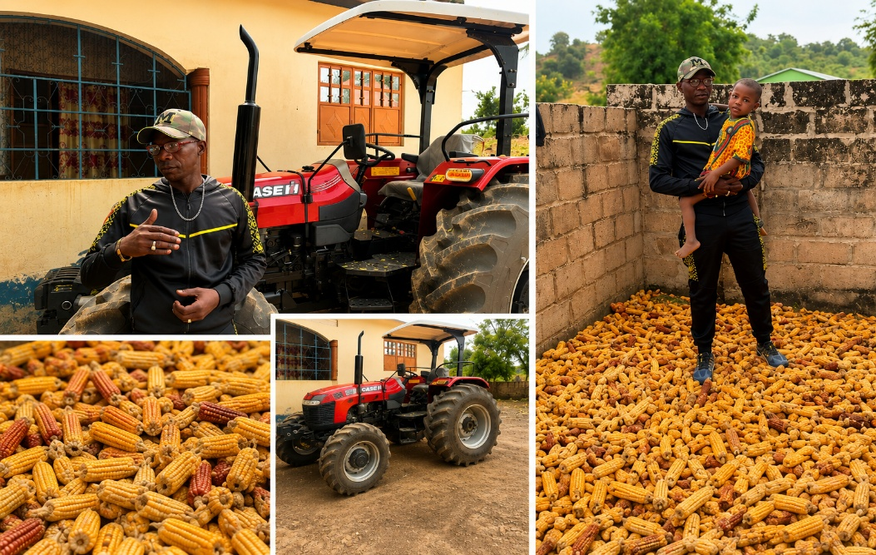
In Bakadaji Village, Basse, livelihoods have long depended on the soil. Agriculture is the backbone of the community, yet for many families, access to tools that turn effort into productivity which has always been limited. During the PACD output verification exercise, the team met Bolong Keita, the community’s PACD tractor driver and manager. Known in Bakadaji as a mechanic, Bolong’s primary livelihood for years came from repairing machines in a place where mechanical services are scarce. His skills kept him going but income was uncertain, and opportunities were limited.
The arrival of the PACD tractor changed that.
With the tractor came stable employment. Bolong was entrusted not only as the driver but also as the caretaker and manager of the machine earning a regular salary that now supports his family and brings dignity and security to his household.
But the transformation did not stop there.
Last rainy season, Bolong took a bold step. For the first time in his life, he decided to farm. Although his family-owned farmland, Bolong had never ventured into agriculture himself. Like many in the community, limited resources and lack of access to equipment made farming a farfetched option. With direct access to the tractor and the skills to operate it they saw possibility where there had once been barriers.
He prepared the land, planted maize, and committed fully to the season.
The result was a bumper harvest: 20 bags of maize, each weighing 50kg, harvested from his first farming attempt.
“This is my first time farming,” Bolong shared proudly. “I never imagined I could achieve this.”
Today, Bolong stands as both a farmer and a service provider—living proof of how access to productive assets can unlock new livelihoods. His experience has given him a deep sense of ownership and responsibility toward the tractor he manages. He protects it, maintains it, and operates it with care not just as an employee, but as a direct beneficiary of the PACD initiative.
For Bolong, the tractor is more than a machine. It is opportunity. It is food on the table. It is proof that with the right support, rural communities can transform from within.
And for Bakadaji, his story is a reminder that when one life changes, an entire community feels the impact. Beyond individual gains, the PACD tractor in Bakadaji is managed through a transparent and inclusive community system. Requests for tractor services are coordinated through the youth leadership, communicated to the operator, and formally recorded by a designated secretary who tracks usage, issued services, and scheduling.
Access is open and inclusive, operating on a first-come, first-served basis, ensuring fairness across households. A community committee comprising a Chairperson, Treasurer, and Secretary oversees operations, finances, and accountability.

STORY 2
A Tractor That Brought Jawlaba Forward
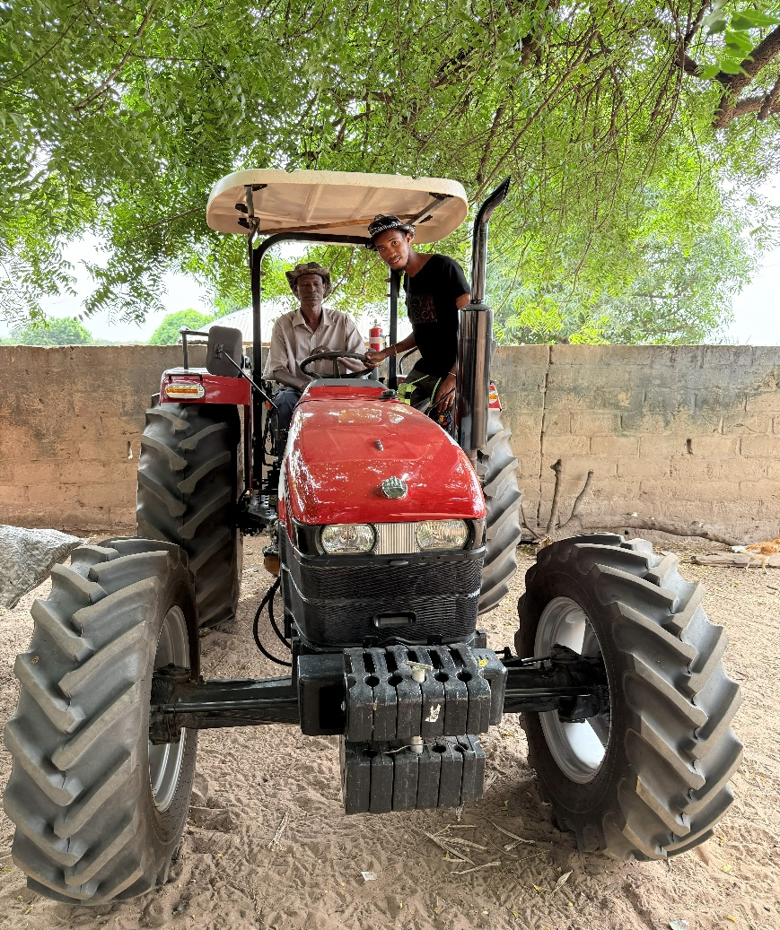
In Jawlaba, a farming community in The Gambia’s North Bank Region, the arrival of a PACD-supported tractor has quietly transformed everyday life. Where farming once relied on exhausting manual Labor, farmers can now prepare land efficiently for groundnut, maize, rice, and millet leading to doubled groundnut harvests and improved yields across other crops.
The tractor serves more than 80 households, benefiting about 540 people, and has helped the community make a saving of GMD180,000 from rentals of the tractor to neighbouring villages that could generate income. Beyond agriculture, it has been used to repair access roads, improving connections to markets and essential services in an area with limited health facilities and water challenges.
The PACD donated Tractor operated by Mamadou Bah and Tijan Bah, the tractor is carefully managed as a shared community asset under transparent local leadership. For farmers especially women and older residents it has reduced physical strain, saved time, and restored dignity to farming.
In Jawlaba, the tractor is more than a machine. It is a symbol of collective effort, resilience, and how the right support can help a community move forward together.
Local ownership is central to the sustainability of the tractor as a shared community asset.
“This tractor belongs to the whole community. When it works well, it means families will harvest more and suffer less.”  — Mamadou Bah, Tractor Driver | “We don’t just plough farms. We help open roads and support the village. When the tractor is moving, the community is moving.”  — Tijan Bah, Tractor Driver

ANNEX 5: PHOTOS
